Running a Youth Theatre: Co-Creating with Young People with Mortal Fools
9 April 2024 – Session Summary
Introduction
- Hello, housekeeping and Social GRACES from Gabi at Company Three
- Hello from Helen Ferguson, Creative Producer at Mortal Fools, who are a creative learning drama and theatre company who work with children and young people usually between the ages of 7-19. Based in Northumberland.
- Ice breaker: everyone sharing in the chat where they’re from and what they do. There are a range of people working for organisations and freelance from all over the UK.
- Hello from Scott (Practitioner and Coordinator), Jess (Assistant Practitioner) and Mark (a young trustee, previous Mortal Fools member and someone an assistant practitioner)
Warm up activity
- Warm up activity led by Scott called Anyone who - useful when you’re starting a devising process and want to find out more about people’s interests.
- Everyone covers their camera with their finger. Scott reads out a statement. If the statement is true for that person, they should uncover their camera. If the statement isn’t true, they should leave the camera covered.
- Scott gives a series of statements:
Anyone who works in youth theatre
Anyone who would consider themselves a director
Anyone who has written lyrics before
Anyone who has ever forgotten their lines on stage
Anyone who has created a film with young people
Anyone who has made a friend whilst doing something creative
Co-Creating with Young People presentation
For Mortal Fools, co-creation process involves two main areas of practice:
- Creative or artistic practice – the exercises, tasks, rehearsals, how you make work
- Relational practice – what needs to be in place, the culture, environment, the ways we work together as human beings in order to achieve a successful creative process
One cannot be achieved without the other. We hope that our work leads to a strong artistic output but also strong well-being outcomes for the young people and staff.
Our purpose is about improving interpersonal connections and relationships. And we use drama and related art forms to achieve this because they are interpersonal in nature.
Why we do what we do, and why co-creation is so important
Helen shares quotes from a 17 year old Mortal Fools Youth Theatre participant, an audience member and a Youth Theatre parent, demonstrating contribution to wellbeing, access to the arts in under-served communities and for those facing barriers, and inclusive practice.
How we make that a reality
PERMA framework – a ratified framework that we have borrowed and embedded into everything we do in a structured way. Based in positive psychology, an acronym for the 5 building blocks of wellbeing.
- Positive emotion – not just about feeling positive in the moment, but also about things like feeling positive about your future, who you are, self-esteem
- Engagement – being involved, focusing on something, putting your time and your energy and your attention to something. But we also recognise that it needs to include some level of challenge. About balance between challenge and support with young people.
- Relationships – working as a group, making friends, building trusted relationships with others including adults
- Meaning – the work having personal relevance to the people involved, but also being related to something bigger than ourselves.
- Achievement – could be acting in the final performance or film, but looks different to different people. For some just staying in the circle is a huge achievement
We’ve developed a toolkit to use this framework, including a practice guide which includes tools to help you embed it into your work. Currently trialling a pilot version of it, hoping to then make it available to be purchased by other organisations.
Feedback from young people and evaluation – we have a poster up in sessions, so young can submit votes around this framwork at the end of their session to reflect on their experience. This gives us a chance to listen to young people, so they can feed into the process and we can monitor what they're getting out of sessions.
Mechanisms for each area
- Positive emotion – planning activities that have been enjoyed before
- Engagement – varying types of activity, to different preferences or strengths in young people
- Relationship - in approaches that foster inclusion and help people be themselves. So an example of that is to run a game or an activity in a way that includes people who might be neurodivergent.
- Meaning - planning appropriate practical activities to help young people reflect on their lives, the wider world or the theme of the activity to produce meaningful content when they're devising.
- Achievement - identifying opportunities for people to work within their strengths e.g. a writing task for someone who is good at writing and enjoys it
Session plan
- We use a session plan outline which tracks the PERMA framework. Makes it really quick for practitioners to plan a session whilst being intentional about what they’re doing and outcomes.
- At the end of the session, they can use the form to track young people’s votes and see what is working well.
- Means we have lots of data and information for reporting, making a case for support

Artistic and inclusive practice more generally
A few areas of our practice to highlight:
- Integrating different artistic approaches / styles / artforms – working across art forms means the young people are exposed to loads of different ways of making work, and also enables you to to suit the needs of the circumstances and needs of the group.

- It’s important to us that we’re listening to young people’s ideals, lived experiences – and encouraging them to share their beliefs, self-expression, and the things they want to express through creating art and theatre.
- Inclusive practice - We think about what everyone will need to be able to thrive as themselves. We might provide a balance or mixture of different activities that cater to different preferences, like different games, different content, different types of rehearsal.
Practical solutions
Important to work in innovative ways and provide a balance of challenge and support. When young people’s lives are complex and unpredictable, it’s really important to be adaptable.
For example, we had a member who wanted to be involved in a project but was going to be in hospital for an operation. We made sure she was only in scenes with one person who was her friend, so she could rehearse from a hospital bed and learn the lines. She wrote some spoken word which we integrated as a monologue.
Audience
We've really developed lots of different ways to share our work with audiences especially because with youth theatre we often have short runs. Some examples – a screening of a film we made, which included a creative response workshop afterwards. It’s important to think about different ways of sharing young people's work and not just having one performance in the method.
Mark – Co-creation at every level of Mortal Fools
- I've been a young person, assistant practitioner and now a young trustee for the company.
- I’ve seen how co-creation allows young people's ideas to be transformed into something real and professional, grow in potential and therefore make them really proud of their work.
- It also allows young people to feel like they are on the same level as the adult, and that there's not this big difference between a young person and adult but rather that they're all one and I think that's really important for the young people to be able to express themselves and have a more creative mindset rather than shadowing their ideas so because they don't think they're good enough for the adults.
- And then this can lead to a lot more complex performances and that have great impacts on the audiences.
Breakout activity
In small groups, participants wrote thoughts and ideas as below:
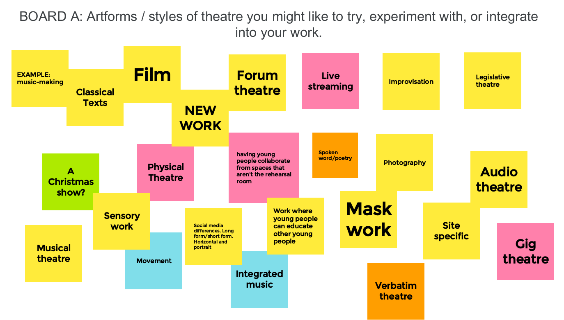
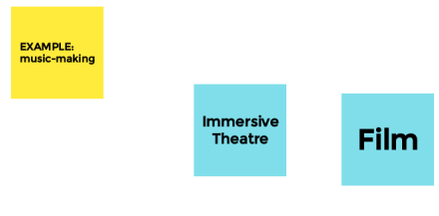
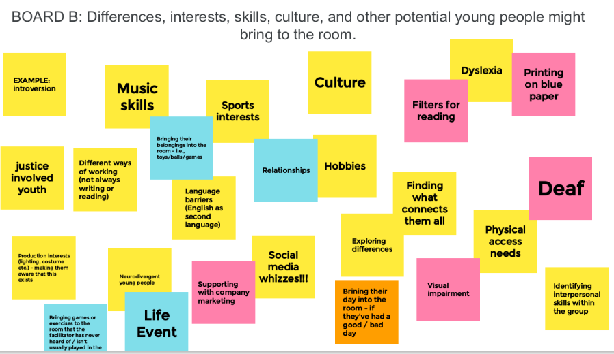
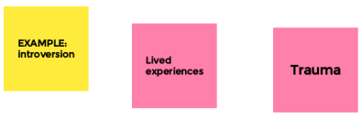
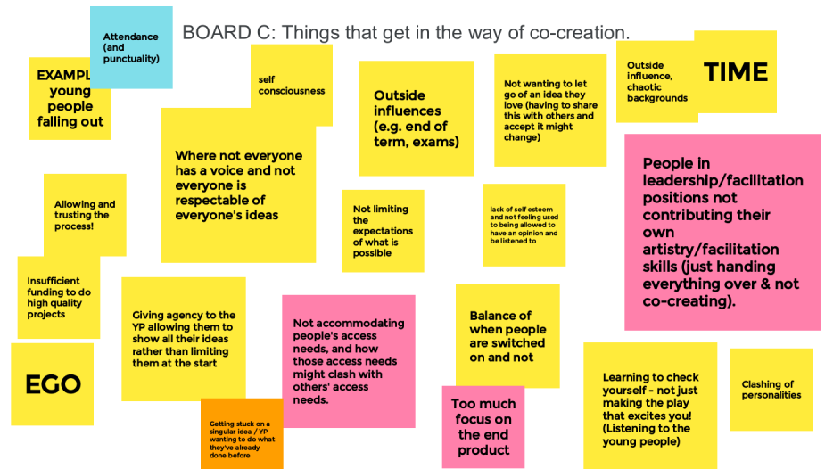
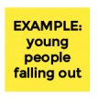

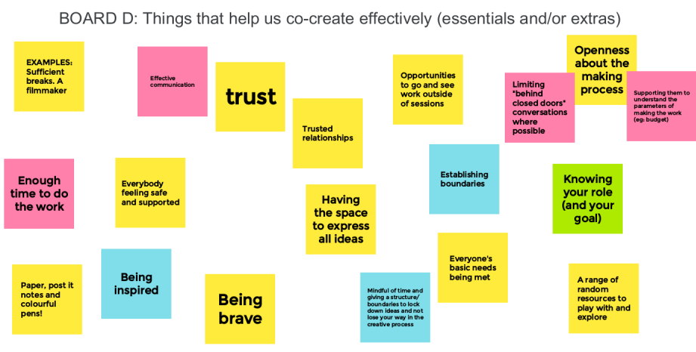
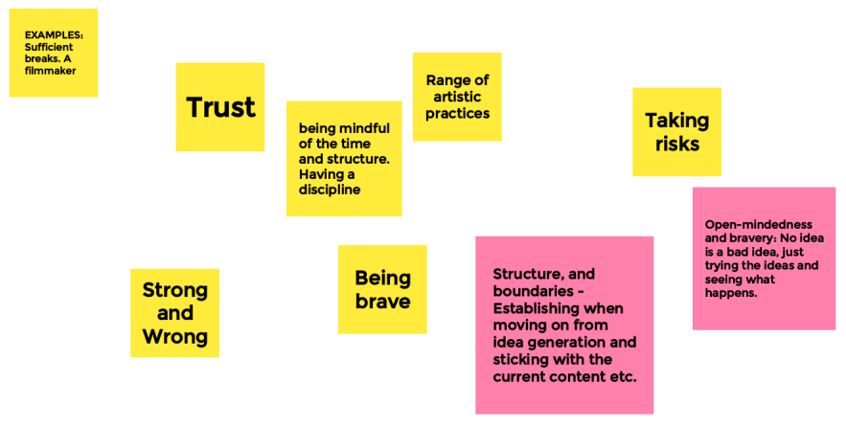
Feedback and questions
Observations from Helen:
- We’re still developing these Running a Youth Theatre sessions – there’s lot from these boards that could inform future sessions, we could deep dive into some of the challenges or areas of potential, if we want to.
- Lots of what we’ve listed as differences could be reframed as what a funder would call a barrier.
- Looking at the challenges page – I really encourage people to think about new approaches or solutions or what is possible here. Quite often means adapting your expectations, but could mean involving and consulting people to adapt what you’re doing.
- People have written lots on board D about structures, culture, environment – which is obviously incredibly important – but there are also artistic things that could help co-creation that we should be advocating for.

Q&A
How does the PERMA framework form work that you mentioned Mortal Fools use at the end of a session?
It’s an Excel spreadsheet that sits on our practitioner Google Drive. So it means the practitioners can all go on there and contribute to it. We looked at a few different options. Eventually I would love to have some sort of software, a portal or something that is designed by tech wizards.
Each group has a big spreadsheet with loads of tabs. So there’s all the indicators and mechanisms, and it means everything feeds through to each other. At the end of the spreadsheet document is an overview of the entire project, which pulls together the percentage of positive emotion or achievement votes from the young people.
How often young people meet and how that impacts how you achieve the outcomes? Because if you meet weekly, a lot can happen between sessions
We have 5 groups that meet every week. We also run creative interventions in schools and youth group settings for 12 week programmes. And then our ensemble young company is a slightly more intensive so they do a full rehearsal during their production time they do a full rehearsal all day on a Sunday and then on a Thursday night.
And yes absolutely, things can change in a week or even in a lunch break. This is where we really value staff development time to really understand the practice so that we're not constantly being reactive, but have got to a point with our practice where we can respond.

But what we have definitely found is that longer a young person stays with us, the better the artistic quality of the work and the bigger the impacts on them.
If the dynamic of a group is struggling, you know if you need to do some work on the relational side of things. It’s about prioritising rather than just thinking ‘oh no, we’ll just keep going.’ It’s more important to help them connect with one another and we’ll do a 10 minute thing with some pre-recorded stuff instead of a full hour long performance. And it will still be really high quality and really impactful. But We're not kind of like just doing what we said we'll do for the sake of it.
How do you come up with prompts for the shows? Do you take a step back and see what’s going on in their lives? Or do you have a brief? Or do you give a prompt?
It varies but it’s always informed and led by the young people. Sometimes it comes from what Ned Glasier who used to run Company Three calls Edgelands conversations – when the young people are chatting, or on their lunch break. Sometimes through devising or a period of R&D. Sometimes from the previous project where a good idea has come up but hasn’t gone the full way.
It’s about finding the sweet spot of what we bring into the room as artists and what the people bring into the room.

